Supplemental material

Table S1. Delphi consensus on responses generated by three large language models to prostate cancer management questions. 2
Figure S1. Proportion of panelists scoring in each category (1–3 = disagreement, 4–6 = no consensus, 7–9 = agreement) per clinical question and large language model after both Delphi rounds. 7

Table S1. Delphi consensus on responses generated by three large language models to prostate cancer management questions.
Guideline-based questions | Delphi results by LLM^{1,2} |  |  | Summary of main panelists’ comments | Panelists  (n)
Guideline-based questions | Claude | Gemini | ChatGPT | Summary of main panelists’ comments | Panelists  (n)
1. What treatment options are available for a patient with metastatic castration-resistant prostate adenocarcinoma who has progressed on apalutamide therapy? | No consensus (60%) | 2nd round (90%) | No consensus (30%) | Claude: Cabazitaxel is incorrectly suggested as first-line therapy; it is only indicated after prior docetaxel.  Gemini and ChatGPT: The first recommendation is not fully accurate, as it excludes docetaxel. | 10
2. Is an FDG PET/CT scan necessary before offering a patient 177Lu-PSMA therapy? | 1st round (100%) | 1st round (100%) | 1st round (90.9%) | Claude: The response is correct but should be more categorical.  Gemini: Provides a clearer explanation than Claude.  ChatGPT: Provides a more direct answer but lacks sufficient explanation. | 11
3. Which combination of an ARPI and a PARP inhibitor can be offered to a patient with metastatic castration-resistant prostate cancer and a pathogenic germline BRCA2 mutation? | 1st round (100%) | 1st round (100%) | 1st round (100%) | Gemini and ChatGPT provide clearer explanations than Claude. | 9
4. What would the clinical stage be in this case?  76-year-old male with a medical history of hypertension (treated with enalapril) and type 2 diabetes (HbA1c 6.8%, on metformin); non-smoker, occasional alcohol use, sedentary lifestyle. Family history includes a father diagnosed with prostate cancer at age 72.  Presenting symptoms: Lower urinary tract symptoms over the past six months, including increased urinary frequency and nocturia three times per night; mild erectile dysfunction, progressively worsening over the past year.  Clinical examination and PSA: PSA level of 17.5 ng/mL (confirmed on repeat); digital rectal exam reveals a grade III/IV prostate without nodules or suspicious findings.  Imaging findings: Multiparametric MRI identifies a 2 cm lesion in the left peripheral zone (PI-RADS 5) with uncertain extraprostatic extension, but no evidence of seminal vesicle invasion.  Systematic transperineal ultrasound-guided biopsy directed at the MRI-identified lesion. 12 systematic cores plus 4 targeted cores.  Systematic biopsy:  - Right lobe: Apex: 2 of 2 cores positive for prostate adenocarcinoma, Gleason 3+4=7. Tumor involvement: 30%. Mid: 0 of 2 cores positive. Base: 0 of 2 cores positive.  - Left lobe: Apex: 0 of 2 cores positive. Mid: 1 of 2 cores positive for prostate adenocarcinoma, Gleason 4+4=8. Tumor involvement: 40%. Base: 1 of 2 cores positive for prostate adenocarcinoma, Gleason 4+4=8. Tumor involvement: 70%.  Targeted biopsy (PI-RADS 5 lesion): 3 of 4 targeted cores positive for prostate adenocarcinoma, Gleason 4+5=9. Tumor involvement: 90% in one core, 100% in the second core.  Additional characteristics:  - Perineural invasion: Present.  - Lymphovascular invasion: Not identified.  - Cribriform pattern: Present and extensive in high-grade disease areas (70%).  - CT scan (thorax, pelvis, and abdomen): confirms no enlarged lymph nodes or distant metastases.  - Bone scan: Negative for bone metastases.  - PET-CT with 18F-PSMA for further staging: Intense PSMA uptake in the left peripheral zone of the prostate corresponding to the MRI-identified lesion. Multifocal uptake with a SUVmax of 18. Subcentimeter lymph nodes in the bilateral pelvic region with mild uptake (SUVmax 2.3). These lymph nodes are probably reactive; no evidence of distant metastatic disease. | No consensus (10%) | 1st round (90%) | 1st round (77.8%) | Claude: Assigns cT3a based on MRI, but staging should rely on digital rectal exam, as imaging is not validated for TNM. | 10
5. What are the differences between PSMA PET tracers? | 1st round (70%) | 1st round (80%) | 1st round (100%) | Gemini explains better than Claude and ChatGPT but includes additional, unsolicited information. | 10
6. What therapeutic options should be considered for the patient presented in question 4? | 1st round (77.8%) | No consensus (66.6%) | No consensus (55.6%) | Gemini: Summarizes all options without tailoring to the specific case and incorrectly assumes the patient has nodal disease.  ChatGPT: Includes staging and radiotherapy details with several inaccuracies and controversial recommendations. | 9
7. In a patient on active surveillance with a stable MRI (PRECISE 3) and a low, stable PSA density (< 0.15), what is the recommended strategy? | 1st round (100%) | 1st round (100%) | 1st round (88.9%) | None of the three models assess lesion visibility per PRECISE 3 v2. | 9
8. When is prostate MRI recommended for diagnostic purposes? | 2nd round (90.9%) | 1st round (80%) | 1st round (70%) | Claude: Draws conclusions not supported by the guideline. | 11
9. What does an extended lymphadenectomy in prostate cancer entail, and does it provide an oncological benefit over limited lymphadenectomy? | 1st round (80%) | 1st round (100%) | 1st round (90%) |  | 10
10. What anatomical and functional factors favor urinary continence after radical prostatectomy? | 1st round (100%) | 1st round (88.9%) | 1st round (88.9%) | ChatGPT: Provides the best summary among the three models, although all responses are valid. | 8
11. Criteria for active surveillance in prostate cancer and when to discontinue it and proceed to active treatment. | 1st round (70%) | 1st round (100%) | 1st round (100%) | Difficult question due to variability across protocols; Gemini provides the best version. | 10
12. For patients with unfavorable intermediate-risk prostate cancer, which imaging tests should be used for staging? | No consensus (63.6%) | 1st round (72.7%) | 1st round (90.9%) | Claude: Fails to mention PET/CT. | 11
13. How should imaging follow-up be performed in patients with metastatic hormone-sensitive prostate cancer treated with doublet therapy? | No consensus (36.4%) | 2nd round (72.7%) | 1st round (81.8%) | Controversial topic with no consensus; difficult for AI to reflect all expert opinions.  Claude: Does not specify follow-up timing; incorrectly recommends PSMA-PET/CT as the standard for follow-up.  Gemini: States follow-up every 3–6 months, which could imply 6-month intervals are acceptable when they are not.  ChatGPT: does not specify follow-up intervals. | 11
14. What are the differences between LHRH agonists and androgen receptor inhibitors in terms of efficacy and side effects? | No consensus (66.6%) | 1st round (77.8%) | No consensus (44.4%) | Claude and ChatGPT: Fail to address the question fully; includes unrelated content. | 9
15. In a 79-year-old patient with de novo metastatic hormone-sensitive prostate cancer, PSA 40 ng/mL, 4 bone metastases, ISUP 4, and comorbidities including hypertension, type 2 diabetes, and early dementia, according to the EAU guidelines, what pharmacological treatment options are recommended, and what are the advantages and disadvantages of each considering the patient’s overall health and comorbidities? | 2nd round disagreement (88.9%) | 1st round (77.8%) | 2nd round (88.9%) | Question not explicitly addressed in guidelines; requires significant clinical context to answer.  Claude: Supports ADT + docetaxel, but current guidance favors triplet therapy if docetaxel is used. | 9
16. I have a patient in a follow-up visit with a prostate biopsy performed by fusion targeting only the lesion. The result is ISUP 1 in all 3 cores submitted. Should I have taken systematic or perilesional cores? Should I repeat the biopsy? | 1st round (90%) | 1st round (70%) | 1st round (70%) | Question not explicitly addressed in guidelines; requires significant clinical context to answer.  The three models contain inaccuracies and lack clarity regarding biopsy recommendations | 10
17. A patient receiving apalutamide presents to the clinic with pruritus and erythema on the chest and upper limbs. How should I manage this? Should I reduce the dose? Should I prescribe an antihistamine? | No consensus (66.6%) | No consensus (44.4%) | No consensus (55.6%) | Question not explicitly addressed in guidelines; requires significant clinical context to answer. | 9
18. An 83-year-old male on multiple medications, PSA 18, with imaging studies showing bone metastases. What steps should I take before choosing treatment in this patient? | No consensus (50%) | 1st round (72.7%) | No consensus (60%) | The question lacks clinical information. None of the three models considers prior biopsy as a necessary step.  Claude: Inappropriate use of PSMA-PET outside guideline recommendations  ChatGPT: misrepresents evidence for darolutamide use outside triplet therapy context. | 10
19. In what situations would bone densitometry be indicated in a patient with prostate cancer? | 1st round (72.7%) | 1st round (72.7%) | 1st round (90.9%) |  | 11
20. For a 57-year-old patient diagnosed with prostate adenocarcinoma Gleason 7 (3+4) / ISUP 2, cT2a, PSA 11 ng/mL, and no comorbidities, what would be the best treatment option? | No consensus (40%) | 1st round (90%) | 1st round (80%) | Claude: Fails to consider radiotherapy as a treatment option. | 10
21. What is the recommended management for low-risk biochemical recurrence in prostate cancer according to the European Urology Guidelines? | 1st round (80%) | 1st round (80%) | 1st round (80%) | ChatGPT: Fails to address biochemical recurrence after radiotherapy; response is vague and includes unnecessary information | 10
22. What is the criterion for defining biochemical recurrence after radical prostatectomy? | 1st round (81.8%) | 2nd round (72.7%) | 1st round (72.7%) | Claude: Definition is unclear, mixes PSA persistence with recurrence. | 11
23. What initial treatment option would you recommend for a patient diagnosed with locally advanced cN1 prostate cancer? | 2nd round disagreement (88.9%) | 1st round (100%) | 1st round (100%) | Claude: Incorrect management approach. | 9
24. I have localized prostate cancer with a PSA of 10 and my cousin has prostate cancer. I am worried; do I need a genetic test? | 2nd round disagreement (80%) | 1st round (90%) | 1st round (80%) | Claude: Incorrect management approach. | 10
25. I have prostate cancer 4+3=7 in 1 out of 12 cores. Can I be included in an active surveillance protocol? | 1st round (90.9%) | 1st round (100%) | 1st round (72.7%) | Claude and Gemini provide clearer answers than ChatGPT. | 11
Abbreviations: 177Lu-PSMA, Lutetium-177 Prostate-Specific Membrane Antigen; ADT, Androgen Deprivation Therapy; ARPI, Androgen Receptor Pathway Inhibitor; BRCA2, Breast Cancer Type 2 Susceptibility Gene; CT, Computed Tomography; FDG, Fluorodeoxyglucose; EAU, European Association of Urology; HbA1c, Hemoglobin A1c; ISUP, International Society of Urological Pathology; LHRH, Luteinizing Hormone-Releasing Hormone; MRI: Magnetic Resonance Imaging; PET, Positron Emission Tomography; PARP, Poly (ADP-ribose) Polymerase; PI-RADS: Prostate Imaging-Reporting and Data System; PSA, Prostate-Specific Antigen; PSMA, Prostate-Specific Membrane Antigen; SUVmax: Maximum Standardized Uptake Value

¹ 1st round’ or ‘2nd round’ indicates consensus was reached in the first or second Delphi round, respectively.
² The percentage in parentheses indicates the proportion of panelists whose scores fell within the same tercile as the median of responses (1–3 = disagreement, 4–6 = no consensus, 7–9 = agreement).

Color code for consensus levels:
- Dark green: Consensus in agreement reached in the first round.
- Light green: Consensus in agreement reached in the second round.
- Light orange: Consensus in disagreement reached in the second round.
- Yellow: No consensus reached.

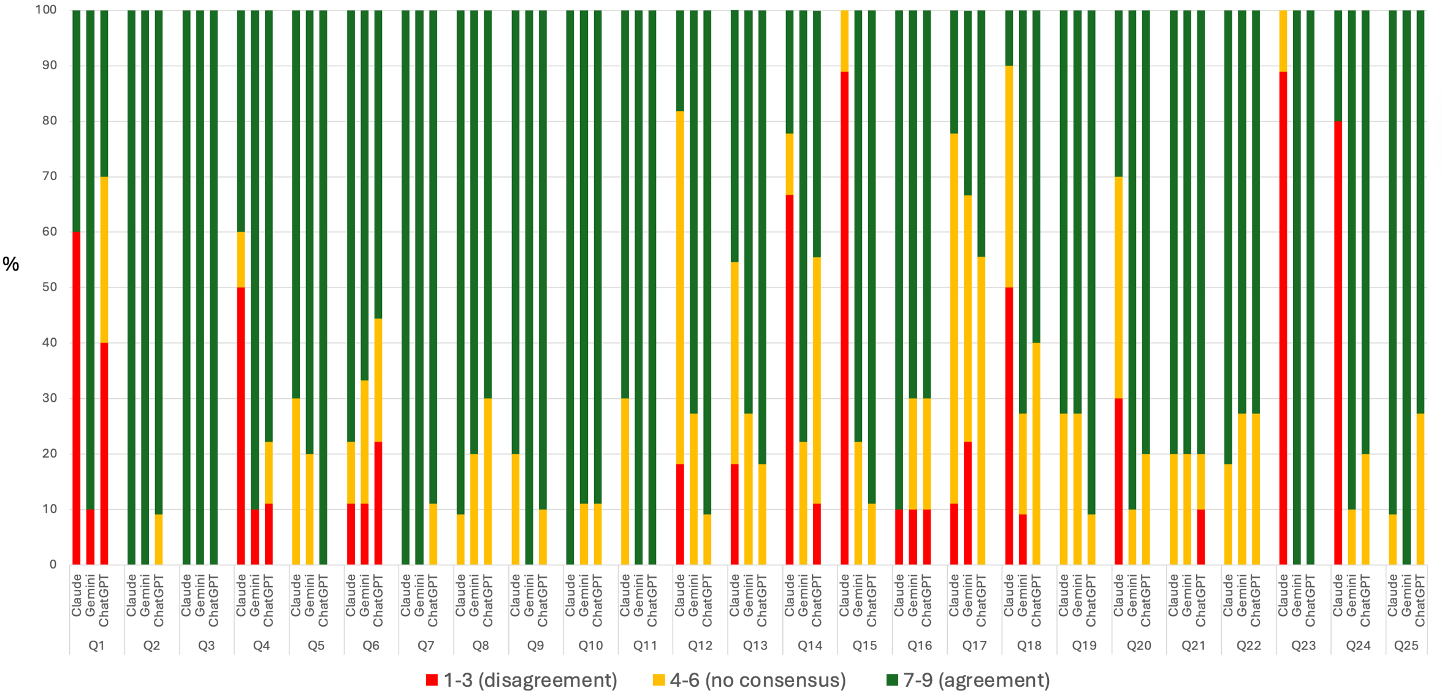
Figure S1. Proportion of panelists scoring in each category (1–3 = disagreement, 4–6 = no consensus, 7–9 = agreement) per clinical question and large language model after both Delphi rounds.

